Section 10: Loops

* Loops are useful for performing a particular task or set of tasks multiple times
* There are two loops: for loops and while loops
* For loops: the idea is that we have a collection of data that we can iterate over (loop through)
  + A list of numbers
  + A string (each letter of the string)
* For loop usage

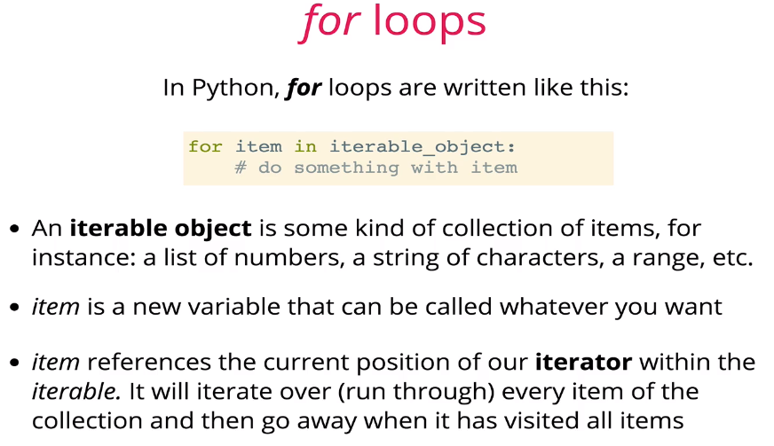

* + Each time through the loop, the *item* will represent a different position in the iterable based on where we are in the variable
* For loops with ranges

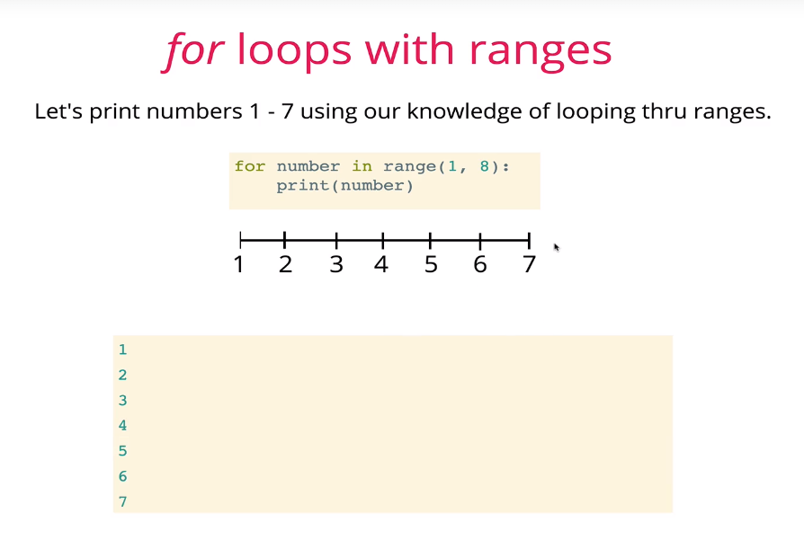

* Ranges are most often used with *for* loops
  + They are simple ways for generating ordered sequences of numbers
  + Syntax: range(start, end (non-inclusive), step)

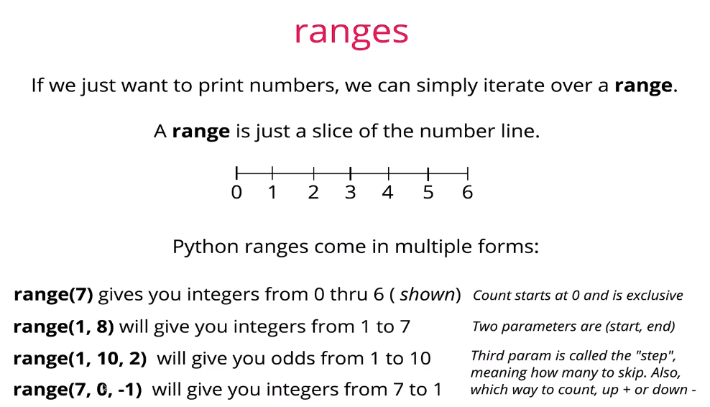

* Refer to file range.py
* While loops
  + While loops allow us greater versatility for iteration compared to for loops, but you have to be more careful with it

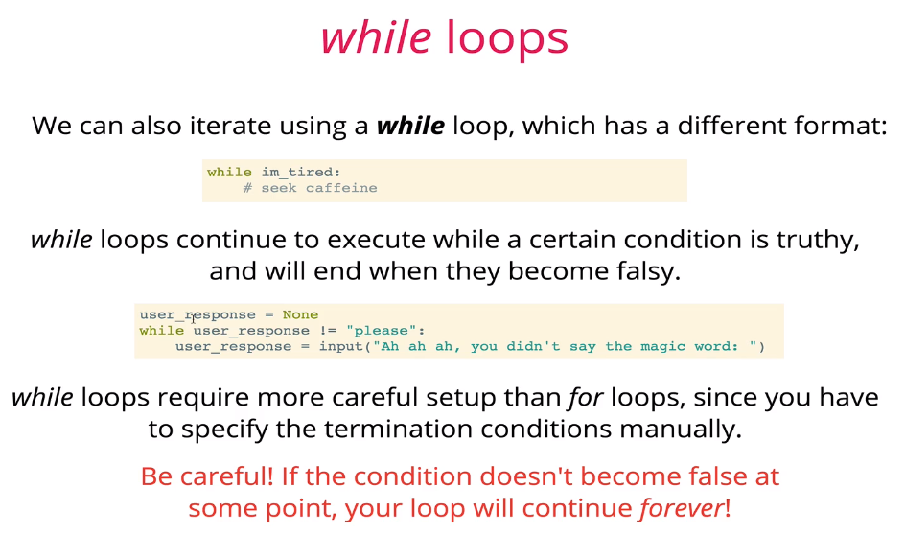

* + Refer to while.py
  + While loops are more flexible because you don’t have to set the absolute number of times the loop will run, as in a for loop
* Controlled exits from loops
  + Using the “break” keyword will cause your program to exit a loop
  + Useful for avoiding infinite loops or putting stopping points on loops
  + “Break” will exit the loop immediately – it will not finish its current iteration

